Final-Year Project Documentation
AI-Powered Gym Assistant – PoseFit AI
Real-Time Exercise Recognition and Logging

By
Artem Shkurat (SHK22612576)

Submitted to
The University of Roehampton

In partial fulfilment of the requirements
for the degree of
BACHELOR OF SCIENCE IN SOFTWARE ENGINEERING

Declaration

I hereby certify that this report constitutes my own work, that where the language of others is used, quotation marks so indicate, and that appropriate credit is given where I have used the language, ideas, expressions, or writings of others.

I declare that this report describes the original work that has not been previously presented for the award of any other degree of any other institution.
Signed (apply signature below)


Artem Shkurat
Date: 30.01.2026

Acknowledgements

Here it is customary to thank the people who have supported this work and your studies in general. It is up to you who you thank!

Abstract
GUIDANCE: Up to 300 words
A short summary of your project to include the problem, the main literature reviewed, your implementation and your findings.
Write this after you have finished the entire report!
Table of Contents
1. Introduction 7
Problem Statement and/or Research question 7
Aims 7
Objectives 7
2. Background and Context 9
Background 9
Literature review 9
Competitor Analysis/ Related work 32
3. Tools and Methods 34
Rationale for the technical tools selected 34
Rationale for the research methods used 35
Project management and Product lifecycle 36
Risk register 41
4. Requirements/Specifications 44
5. Solution design 52
6. Solution implementation 53
7. Solution testing/ evaluation 54
8. Discussion 55
9. Conclusion 55
Summary 55
Recommendations for further work 55
Reflection 55
10. References 56
11. Appendices 57

List of Figures
Figure 1: MediaPipe example image 10
Figure 2: MediaPipe real-life use example 10
Figure 3: MediaPipe body skeleton keypoints Figure 4: MediaPipe settings 11
Figure 5: OpenPose main menu 12
Figure 6: OpenPose keypoints detection 12
Figure 7: OpenPose body keypoints examples 13
Figure 8: Tempo intro question 14
Figure 9: Tempo personal AI coach free trial 14
Figure 10: Tempo price for a month 14
Figure 11: Freeletics ratings 15
Figure 12: Freeletics intro question #2 16
Figure 13: Freeletics intro question #1 16
Figure 14: Freeletics intro question #3 16
Figure 15: StrengthLog most popular programs Figure 16: one of the StrengthLog programs 17
Figure 17: StrengthLog workouts Figure 18: StrengthLog workout example 18
Figure 19: StrengthLog workout technique Figure 20: StrengthLog workout instructions 19
Figure 21: Muscle & Strength muscle groups sorting #1 20
Figure 22: Muscle & Strength muscle groups sorting #2 21
Figure 23: Muscle & Strength all chest exercises 21
Figure 24: Muscle & Strength video exercise guide 22
Figure 25: Muscle & Strength exercise profile and target muscle group Figure 26: Muscle & Strength exercise instructions 22
Figure 27: Strong workout menu Figure 28: Strong workout logging 24
Figure 29: Strong finish workout screen Figure 30: Strong after workout logging screen 25
Figure 31: Strong save workout? Figure 32: Strong workout results 26
Figure 33: Hevy workouts main screen Figure 34: Hevy exercise choice 27
Figure 35: Hevy workout logging screen #1 Figure 36: Hevy workout logging screen #2 28
Figure 37: Hevy muscle groups used Figure 38: Hevy set types 29
Figure 39: Hevy save workout? Figure 40: Hevy workout results screen 30
Figure 41: Kanban board 36
Figure 42: Gantt chart 37
Figure 43: Risk assessment 42

List of Tables
Table 1: Literature review application comparison table 31
Table 2: Risk register table 42
Table 3: Persona 1 44
Table 4: Persona 2 45
Table 5: Persona 3 46

Introduction
The development of artificial intelligence and the computer vision have made it possible to analyse human movement with the help of smartphones. When it comes to fitness, it becomes a problem to be able to recognize exercises properly, learn how to use the right technique, and monitor the progress of training. The goal of this project is to develop an AI powered mobile app that uses a phone's camera to recognize the exercise a person is performing. After identifying the exercise, the app can display useful information, such as the exercise name, target muscles and the correct technique. This app will also allow users to manually log sets, reps and weights, helping them keep track of their workouts. The aim is to make gym workouts easier, more accessible and more informative for anyone who wants to understand and track their progress.

Problem Statement and/or Research question
Many gym-goers, particularly beginners, struggle with identifying exercises, especially when learning new ones. Remembering exercise names, understanding which muscles are involved, and tracking sets, reps, and weights can also be challenging and not always practical during a workout. Most existing fitness apps don't automatically recognize exercises, meaning users must know their names before saving, which disrupts the workout process. Additionally, many apps lack clear instructions or explanations, forcing users to search for this information elsewhere. These issues can make workouts less effective, more time-consuming, and tedious for users.

Aims
The primary aim of the AI-Powered Gym Assistant (PoseFit AI) application is to make gym users and home exercisers more aware of what they are doing, how to do it correctly, and what they are capable of through a simple, accessible, and secure platform.

Objectives
- Implement automatic exercise recognition using AI
Develop a system that will use pose estimation and machine learning methods to automatically identify gym exercises from videos captured by a mobile device camera.
- Improve user understanding of exercises and technique
After recognising an exercise, provide clear and accessible information about it, including the exercise name, target muscle groups, and instructions and tips on proper technique. This will help users better understand what they are doing and how to do it correctly.

- Enable simple and efficient exercise logging
Allow users to manually record sets, reps, weights, and their personal records after recognising an exercise. This will help them remember their capabilities the next time they perform that exercise.
- Ensure data privacy and security
Develop the app with privacy in mind and adherence to GDPR regulations. Handle camera data responsibly, requesting explicit user consent and avoiding unnecessary storage or transmission of video recordings. This will help app users feel confident that nothing happens without their permission.

- Develop a simple and practical app
Create an app that is easy to navigate and enjoyable to use on both iOS and Android. This will ensure users have a flexible experience.

- Evaluate system performance and usability
Evaluate the accuracy, usability, and practicality of the app through testing and evaluation, ensuring that the app meets the stated goals and user needs before its full launch.

Background and Context

Background
The recent achievements in artificial intelligence and computer vision have given mobile devices much more ability to analyse human movement. Detecting and tracking key body joints in images or videos for pose estimation is finding increasing application not only in science, computes vision and security but also in sports analysis and fitness. Many different cutting-edge frameworks have shown that human pose tracking is possible using standard cameras without any specialized equipment.
Correct execution of exercises in fitness has a great influence on improving results, as well as preventing injuries. However, most gym-goers don't have easy access to professional guidance during their workouts. Therefore, users tend to use mobile applications, online videos, or written instructions to learn exercises and track their progress. Although these tools offer some useful materials, they usually demand manual exercises selection and require users to be already familiar with the name and methods of the exercises.
Current fitness applications tend to concentrate on a single part of the work out experience like instructional material, workout planning or progress tracking. More developed AI-based platforms might provide feedback in real-time but might also often require specialized equipment, subscriptions, or processing via a cloud. Such restrictions may decrease the availability and create an issue of cost, privacy, and data security.
The widespread use of smartphones enables a lightweight, privacy-conscious mobile solution that combines exercise recognition, guidance, and workout logging.

Literature review
To understand the current state of AI-powered pose and movement recognition for the PoseFit AI app, a study was conducted of existing mobile apps and websites that provide one or more of these core features:
- Pose estimation techniques
- AI-guided fitness platforms
- Exercise info platforms
- Weight, reps, sets logging
The review examines the strengths and weaknesses of each application and compares them to determine the most useful features that may be useful in future application development.
Feature 1: Pose estimation techniques
MediaPipe
MediaPipe[1], [2], [3] is a framework developed by Google developers that can estimate human poses in real time. It can detect body landmarks (such as shoulders, elbows, hips, and knees) on multiple human bodies at the same time.
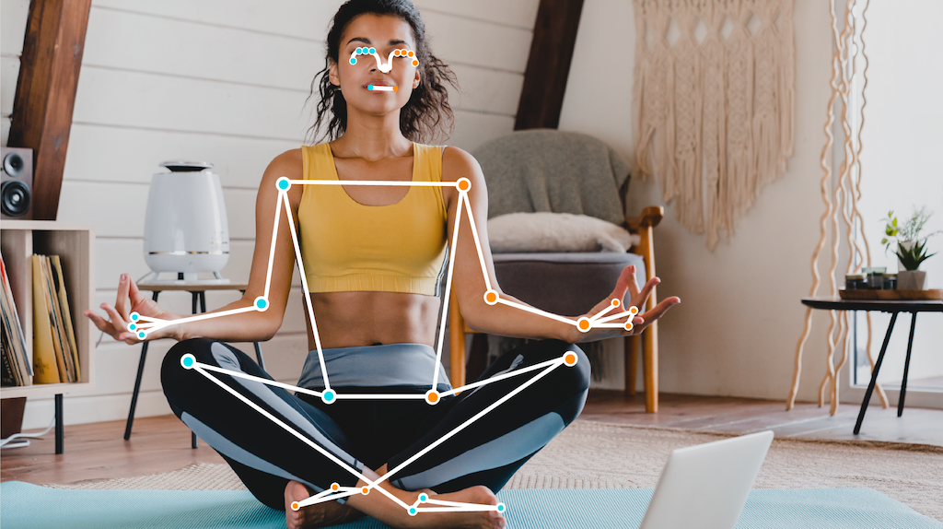
Figure 1: MediaPipe example image
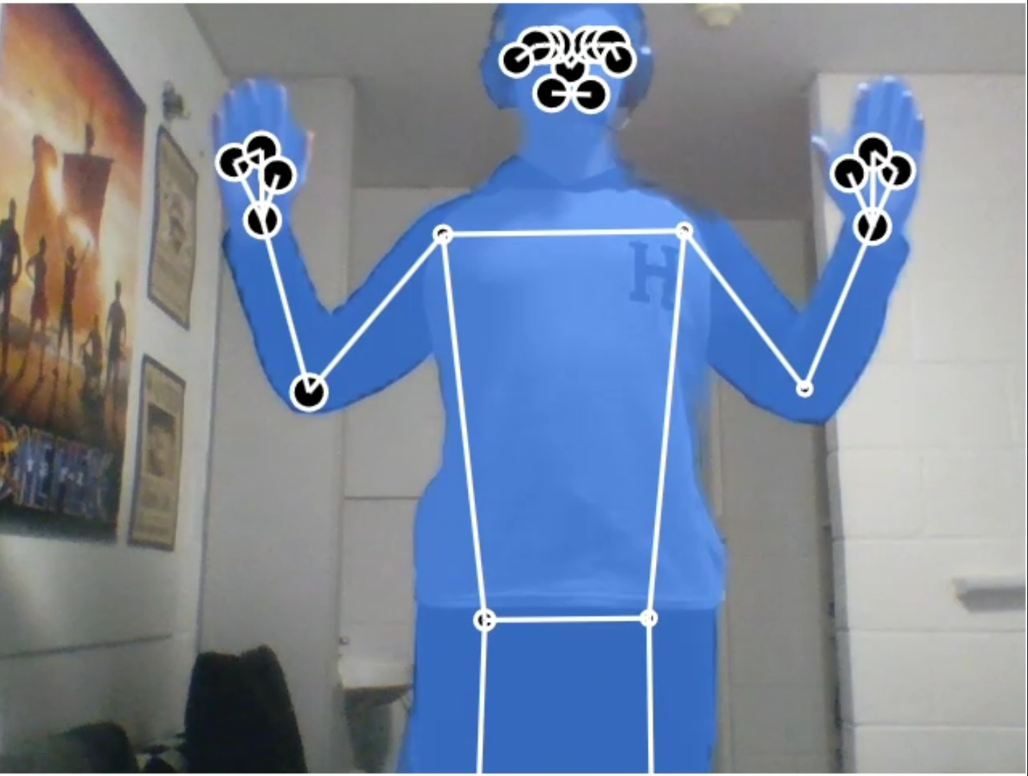
Figure 2: MediaPipe real-life use example
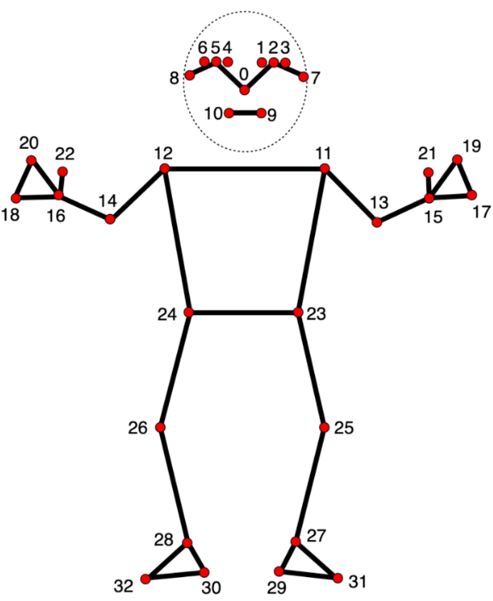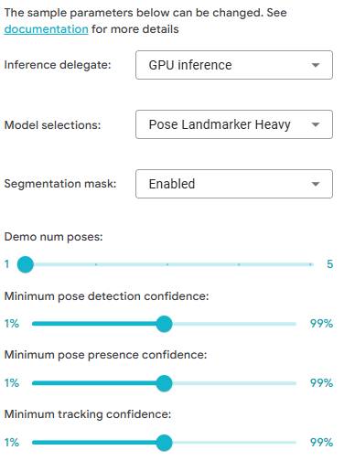
Figure 3: MediaPipe body skeleton keypoints Figure 4: MediaPipe settings

Summary:
MediaPipe uses a trained model that maps your body parts into landmarks in real time. This feature can be used on both a phone and a computer. Landmark detection accuracy is quite high, and the model keeps up with even the most rapid movements of your limbs. However, accuracy drops significantly when it can't accurately detect the ends of your body (for example, when turning sideways). When some parts of your body are out of camera view, the model estimates their approximate location. Lag is almost imperceptible, and this technology doesn't require significant hardware. The model doesn't analyse mouth movements or finger landmarks, only your fist. Additional settings are available, but they're not very extensive.

OpenPose
OpenPose[4], [5] is a pose estimation framework developed by researchers at Carnegie Mellon University (CMU) that can detect and track the human body using photos or videos and accurately determine its pose in 3D space. It is well known for being the first real-time multi-person pose estimation system to accurately detect human body, hand, facial, and foot key points (a total of 135 key points) on single images.

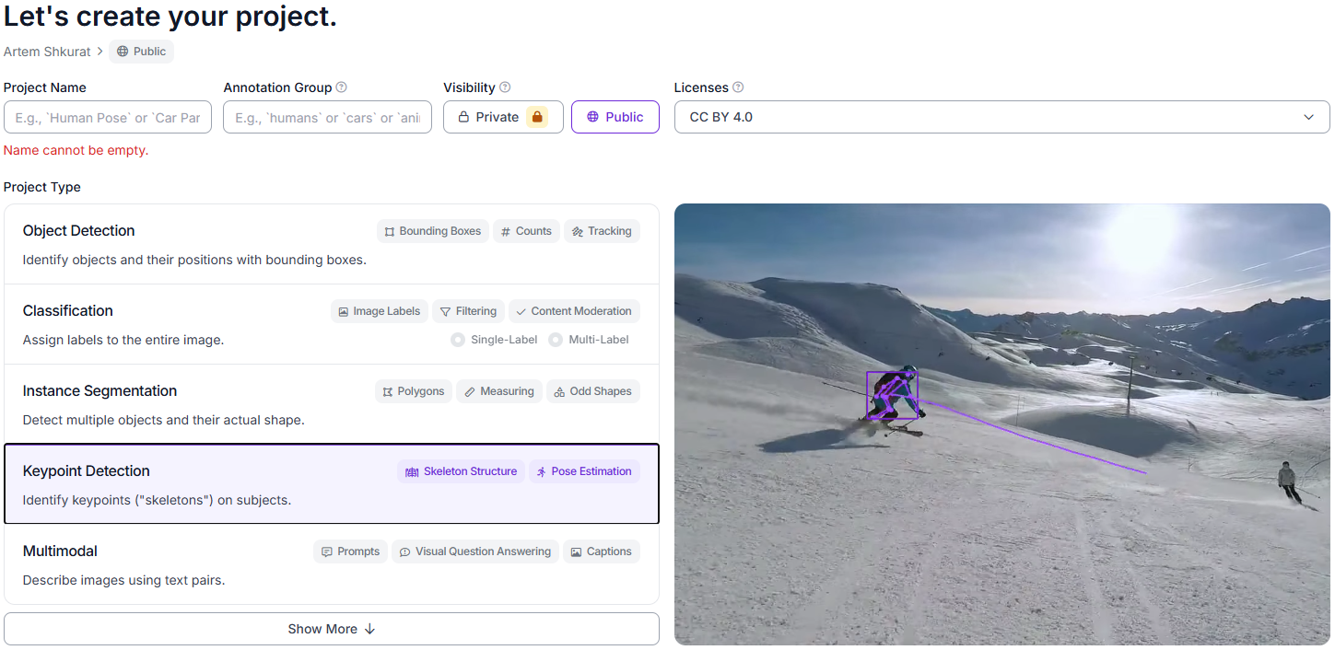
Figure 5: OpenPose main menu

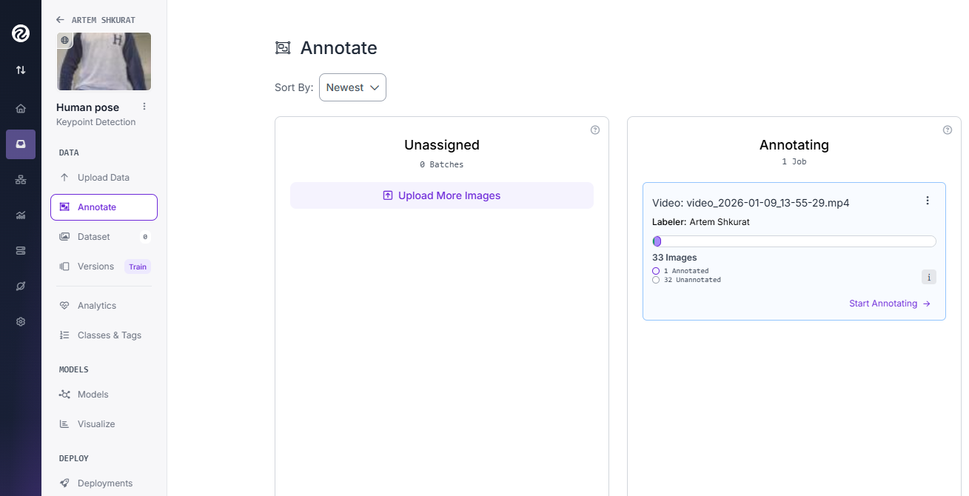
Figure 6: OpenPose keypoints detection

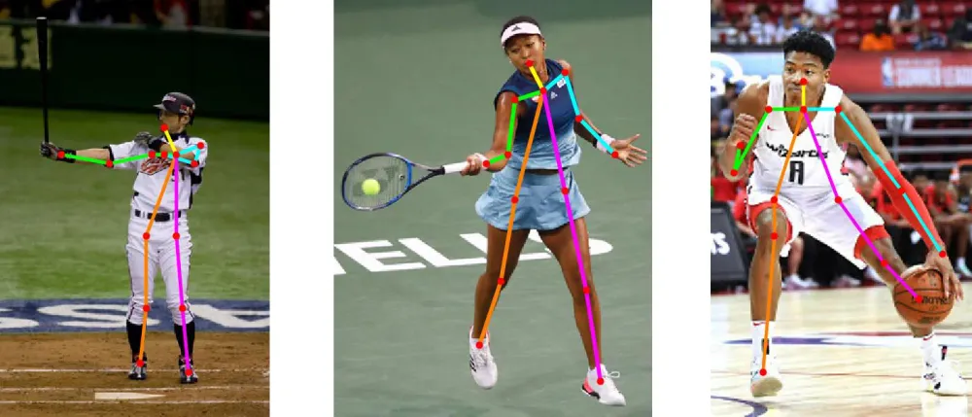
Figure 7: OpenPose body keypoints examples
Summary:
During the utilisation of this tool, it was found that the site and its functionality were not easy to navigate. To work with OpenPose, it requires users to shoot a short video and upload it to their website. These steps include coming up with a project, the project name, an annotation group, and the activities that the uploaded video intends to perform (e.g., Keypoint Detection). Once these steps are completed, the user gets redirected to the main interface in order to accomplish this functionality. This is where the user may encounter several usability issues. The automatic pose keypoint extraction was hard to find and engage in its extraction, and no obvious workflow enabling this option was found. Consequently, it was concluded that keypoint annotation should be done by hand. Also, the absence of real-time pose estimation capability greatly restricts the use of the tool in mobile exercise recognition. All in all, it can be concluded that OpenPose is not an appropriate choice for this project since it features a complicated workflow, as well as lacks the possibilities of real-time processing.

Comparison MediaPipe vs OpenPose:
Although usability concerns were found regarding OpenPose, the general functions of both systems were compared. MediaPipe can be used on both a PC and a phone, while OpenPose is PC-only. MediaPipe also supports real-time processing, which is a huge advantage and well-suited for my project. OpenPose, on the other hand, lacks this capability and only uses photos and videos. Although MediaPipe has high accuracy, statistically, OpenPose's accuracy is even higher; however, the former has significantly lower hardware requirements than the latter. Thus, based on these considerations, it was determined that MediaPipe is the most suitable platform for implementing the proposed system.
Feature 2: AI-guided fitness platforms
Tempo
Tempo[6] is an AI-powered fitness platform that uses computer vision to recognise exercises and guide users through different types of training workouts. It has a built-in AI training assistant that helps users with workout plans, guides them throughout the session, gives tips on improving their technique, and so much more.

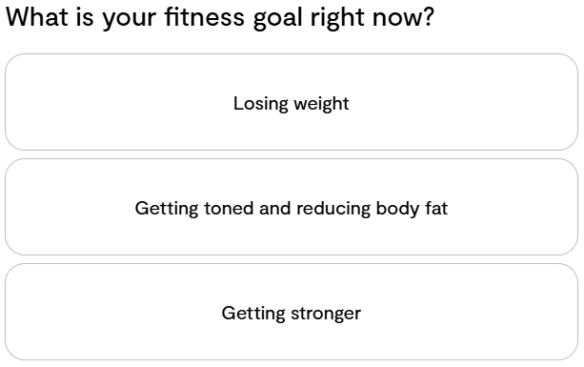
Figure 8: Tempo intro question
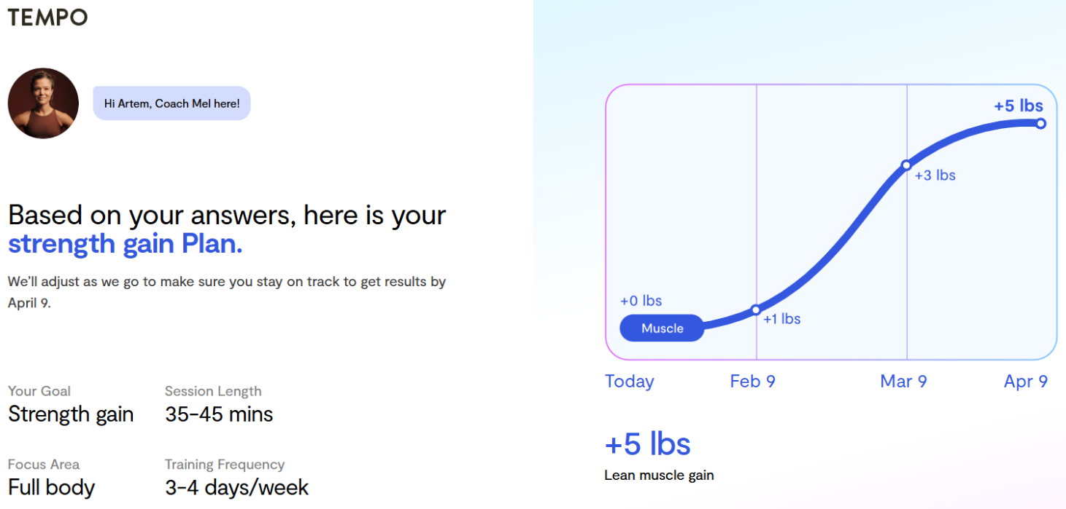
Figure 9: Tempo personal AI coach free trial

Figure 10: Tempo price for a month
Summary:
Since the application is paid and most features are unavailable until a virtual trainer is purchased, it was not possible to fully explore its functionality. Until the paid version is obtained, the application offers few advantages beyond providing an estimate of potential muscle mass gain over a given period. In addition, the subscription is relatively expensive and requires a monthly payment. Another drawback is that the application is primarily designed for home use, and some assistant features require specialised equipment, which must be purchased through the provider’s website. If the paid version is purchased, the application offers a wide range of features, including a virtual assistant that provides guidance and support throughout workouts. Overall, the application follows a similar concept to the proposed project.

Freeletics
Freeletics[7] is a fitness app that uses artificial intelligence to create personalised workout plans based on the user's goals, fitness level, and performance history. Unlike Tempo, it doesn't use a camera to evaluate posture; instead, it collects user data (completed workouts, performance metrics, and feedback) and uses AI-powered algorithms to tailor recommendations for future workouts.

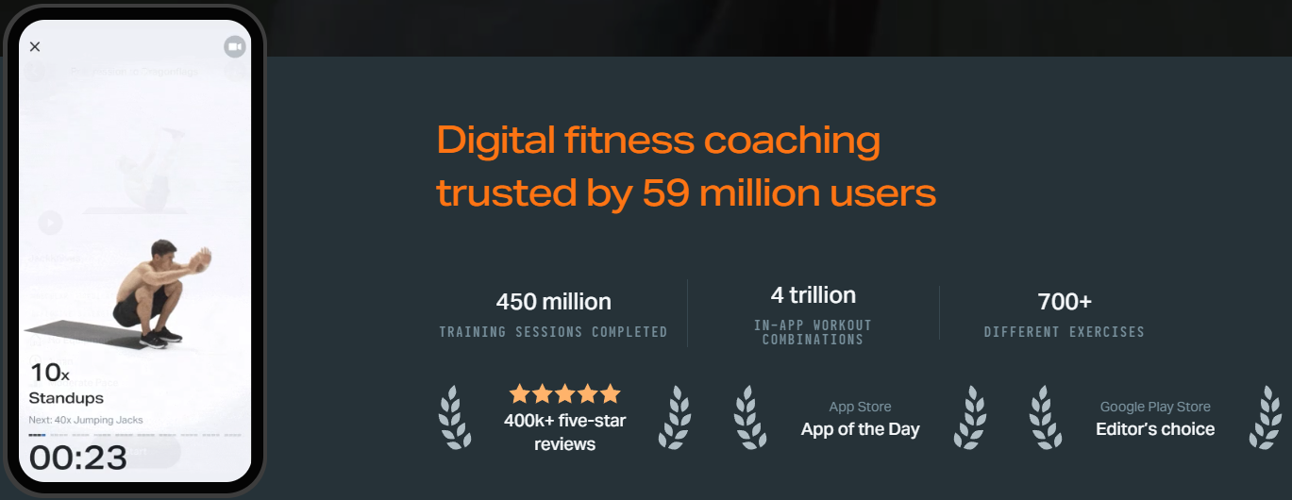
Figure 11: Freeletics ratings

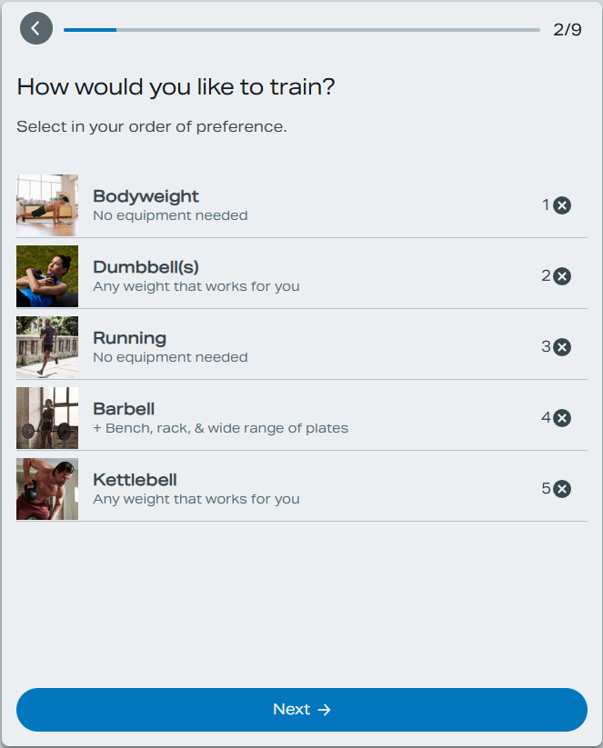
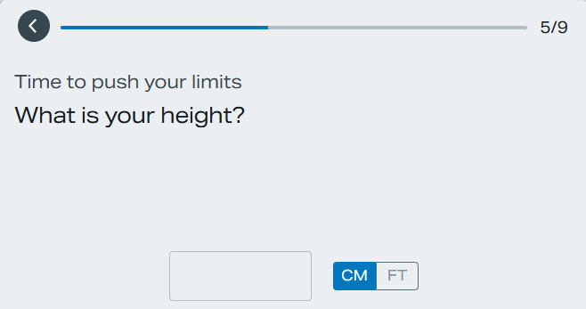
Figure 12: Freeletics intro question #2
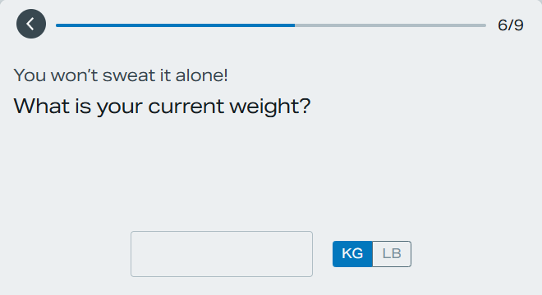
Figure 13: Freeletics intro question #1
Figure 14: Freeletics intro question #3

Summary:
This is a mobile app that requires a fee to use. While the price is lower, this comes at the cost of fewer features. The app doesn't use the camera or AI for posture assessment. It's more focused on building a training program using AI. While it doesn't have a personal assistant, the training plan can be easily modified. Compared to Tempo, this app relies too much on manual control and lacks the AI ​​influence.

Comparison Tempo vs Freeletics:
Although these applications were not fully explored in practice, their overall features were compared. These apps are targeted at different audiences: one is designed for those who need real-time guidance, the other for those who need a training plan. Both apps do their job for a reasonable price. Tempo has a built-in AI assistant that uses the phone's camera, while Freeletics doesn't. On the other hand, Freeletics can be used both at home and at the gym, while Tempo is almost exclusively used at home (due to the necessary equipment). Overall, Tempo’s approach aligns more closely with the concept of the proposed project, although certain design changes would be required.
Feature 3: Exercise info platforms
StrengthLog
StrengthLog[8] is a mobile fitness application with multi-functional content about program following, goals reaching and workout planning. It focused on strength training tracking, and your gym progress. It provides a structured exercise database alongside tools for logging workouts and monitoring progress over time.

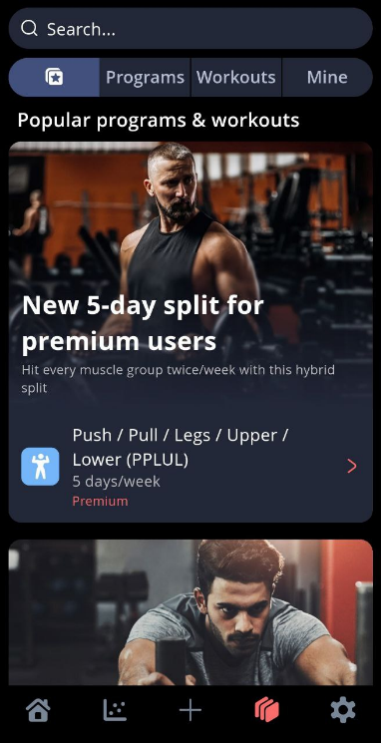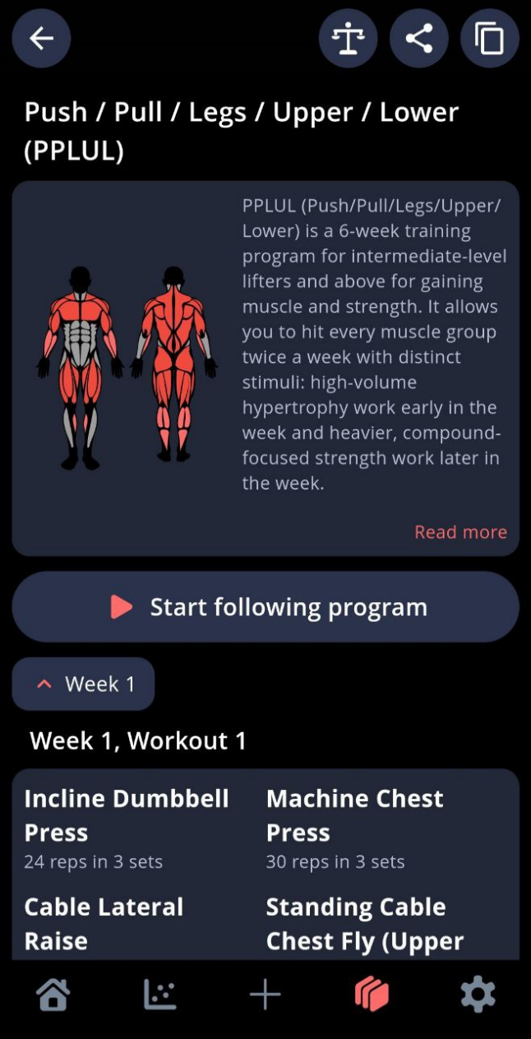
Figure 15: StrengthLog most popular programs Figure 16: one of the StrengthLog programs
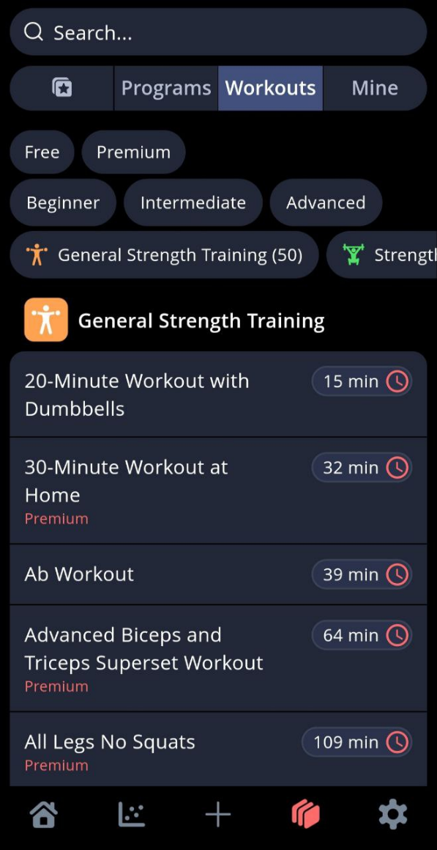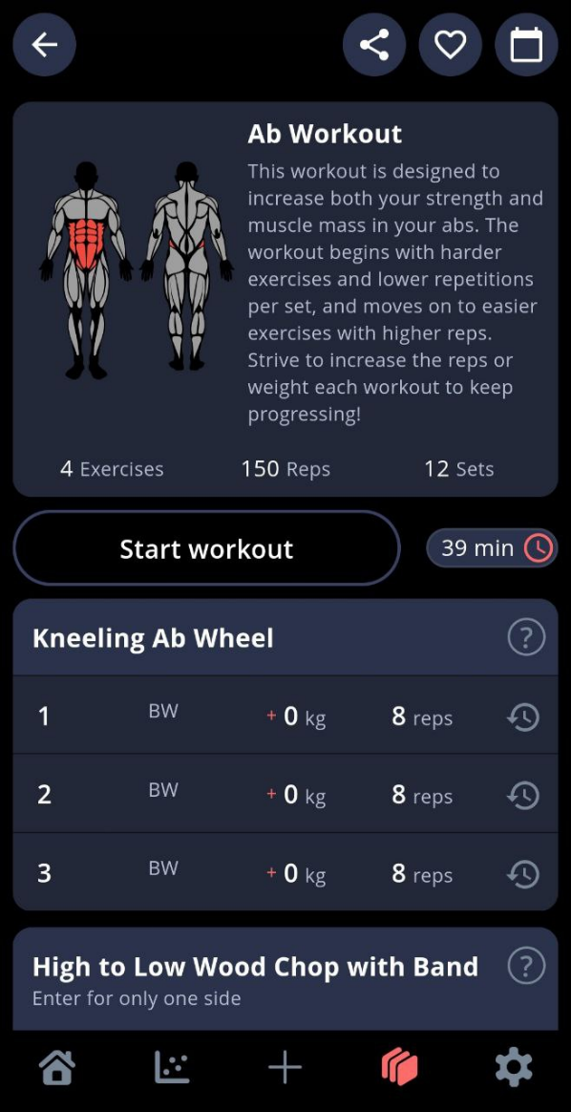
Figure 17: StrengthLog workouts Figure 18: StrengthLog workout example

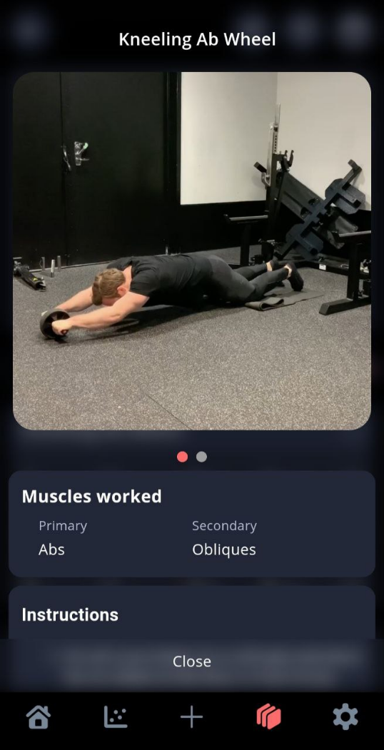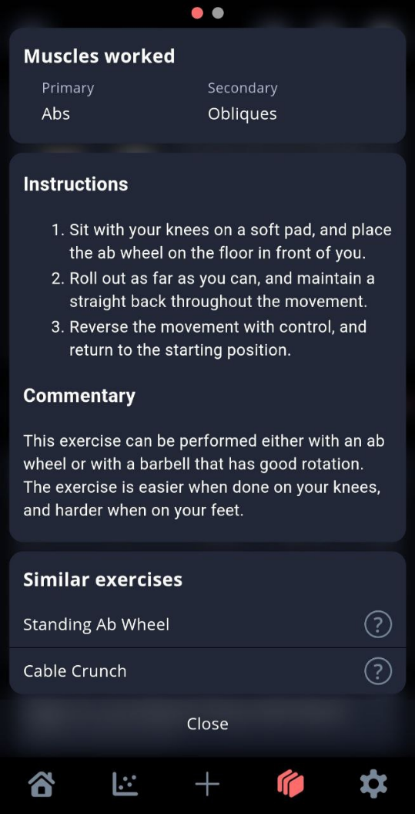
Figure 19: StrengthLog workout technique Figure 20: StrengthLog workout instructions

Summary:
When opening the mobile application, users are expected to register. Upon registration, the user is forced to make some data permissions to enable the application to operate properly. Popular programmes and workouts are clearly presented in a section and the user interface is usually easy to use and understand. In choosing a workout, the application will explain what the workout entails and its duration. Certain exercises are a part of premium membership, with some of the content being free. Once a workout is opened, the application shows the muscle groups to be used, the exercises to be used and the number of sets and repetitions needed. Every exercise incorporates a help icon, which allows a demonstration video and the written instructions on how to do it properly. Altogether, the app has a good user interface as it includes not only guided workouts and educational material but also other support functions.

Muscle & Strength
Muscle & Strength[9], [10] is an educational website dedicated to fitness, offering exercise guides, workout programs, and training tips. The platform provides written guides, images, videos, and downloadable workout plans. Exercises can be categorised by muscle group, equipment used, and workout goals.

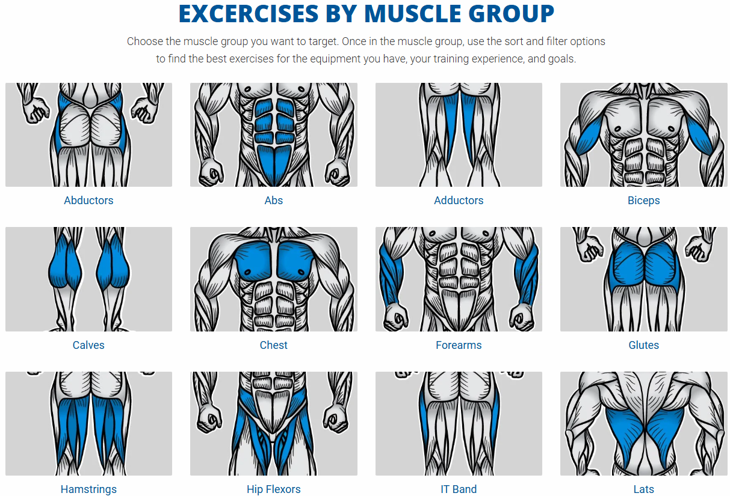
Figure 21: Muscle & Strength muscle groups sorting #1
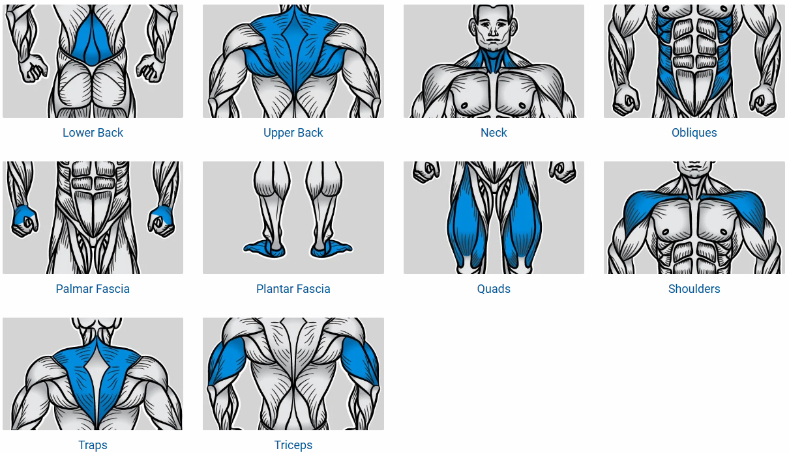
Figure 22: Muscle & Strength muscle groups sorting #2

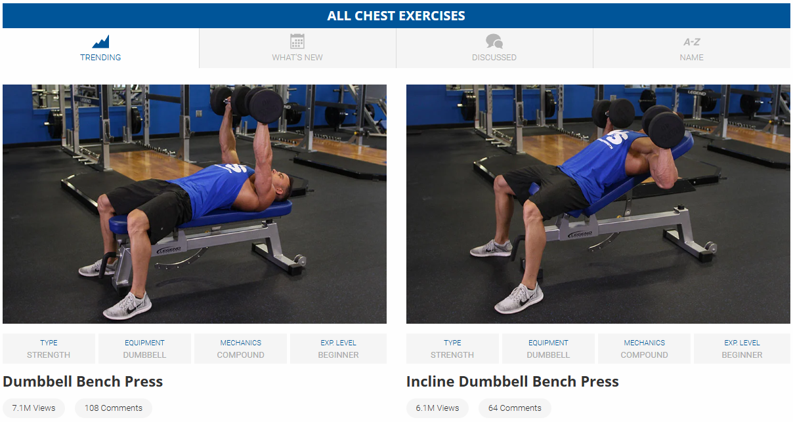
Figure 23: Muscle & Strength all chest exercises

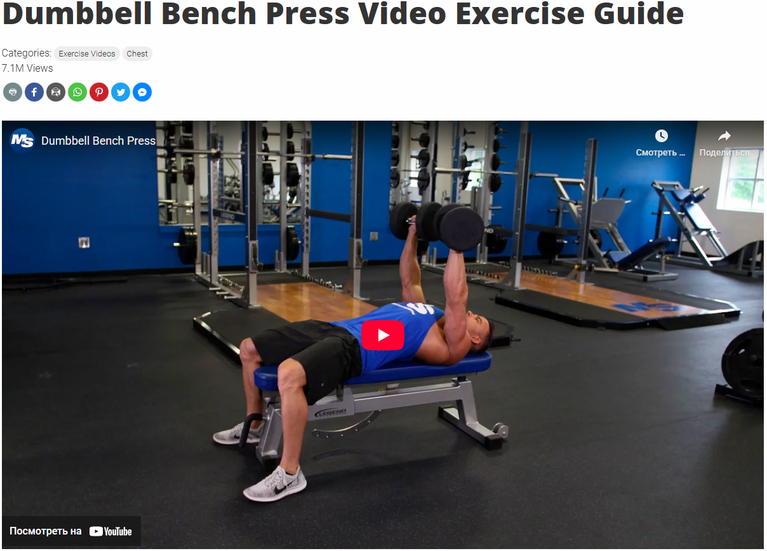
Figure 24: Muscle & Strength video exercise guide
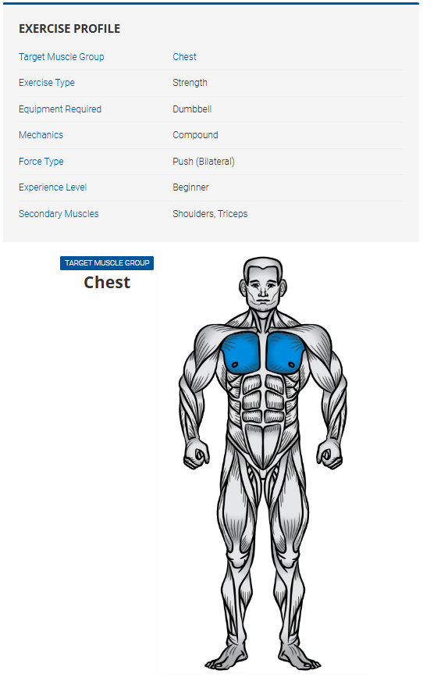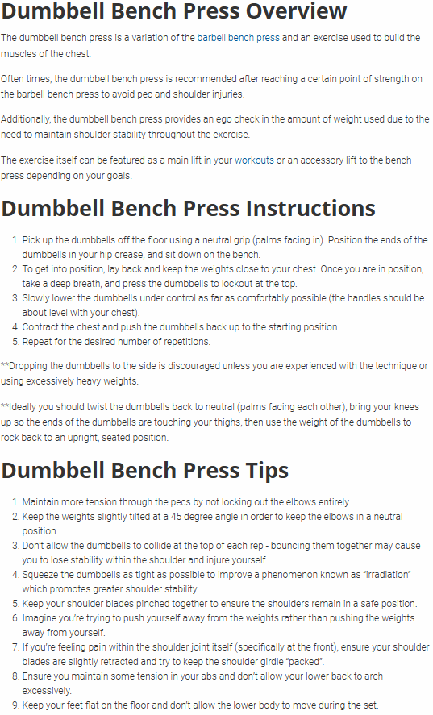
Figure 25: Muscle & Strength exercise profile and target muscle group Figure 26: Muscle & Strength exercise instructions
Summary:
This website provides videos and written instructions for a wide range of exercises using various types of equipment. Exercises are categorised by muscle group, popularity, equipment, and even mechanics (Compound Exercises and Isolation Exercises). For each muscle group, multiple exercise variations are available, allowing users to train the same muscle in different ways. When selecting an exercise, a video demonstration showing correct execution is displayed immediately. Additional detailed information about the exercise is provided below the video. Overall, the website serves as an effective resource for users seeking clear instructions for specific exercises.

Comparison StrengthLog vs Muscle & Strength:
Both of these websites do their job. The difference between them is that StrengthLog isn't focused on providing exercise information and also includes many other useful features. Muscle & Strength, on the other hand, is entirely focused on demonstrating, explaining, and sharing everything there is to know about the exercise. StrengthLog is strictly a mobile app and can be used in the gym. Muscle & Strength can be accessed from any device. StrengthLog requires registration; Muscle & Strength doesn't.

Feature 4: Weight, reps, sets logging
Strong
Strong[11] is a mobile fitness application focused on simple and efficient strength-training logging. It is designed for gym users who want a fast way to record workouts without unnecessary complexity. Users manually select exercises and record the number of sets, reps, and weights during their workouts. The app stores historical data and displays key progress statistics.

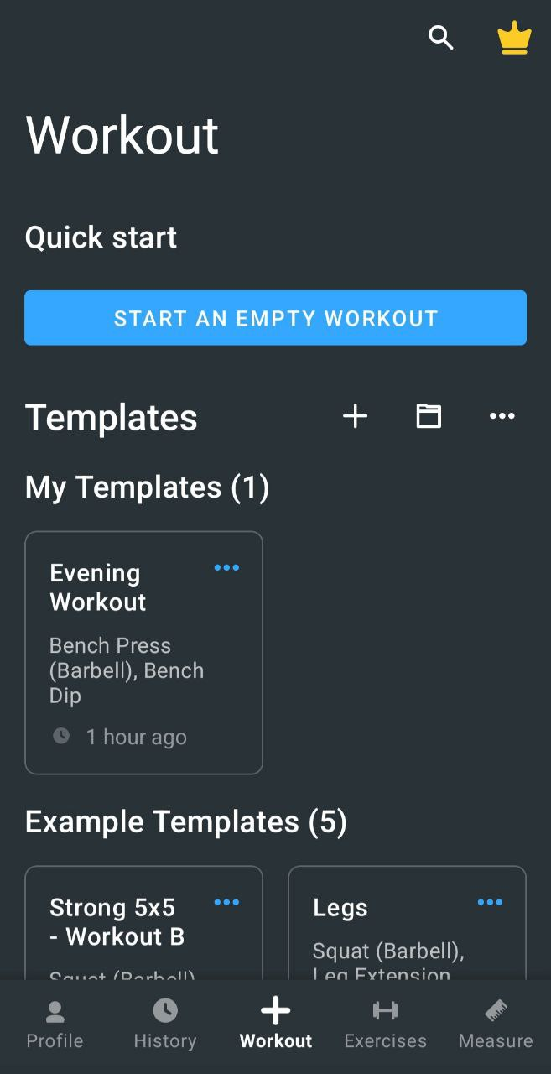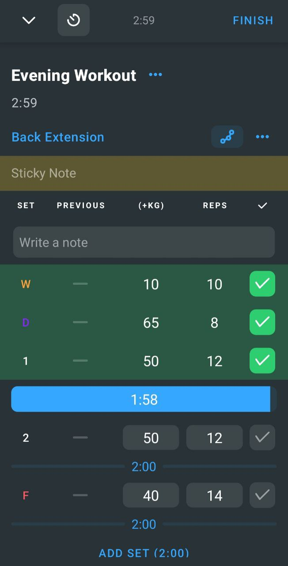
Figure 27: Strong workout menu Figure 28: Strong workout logging
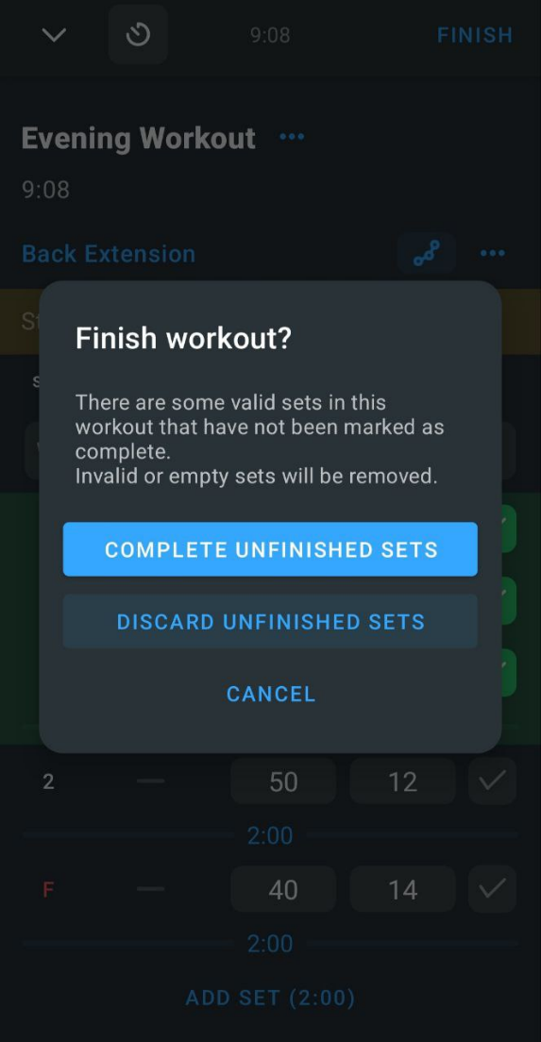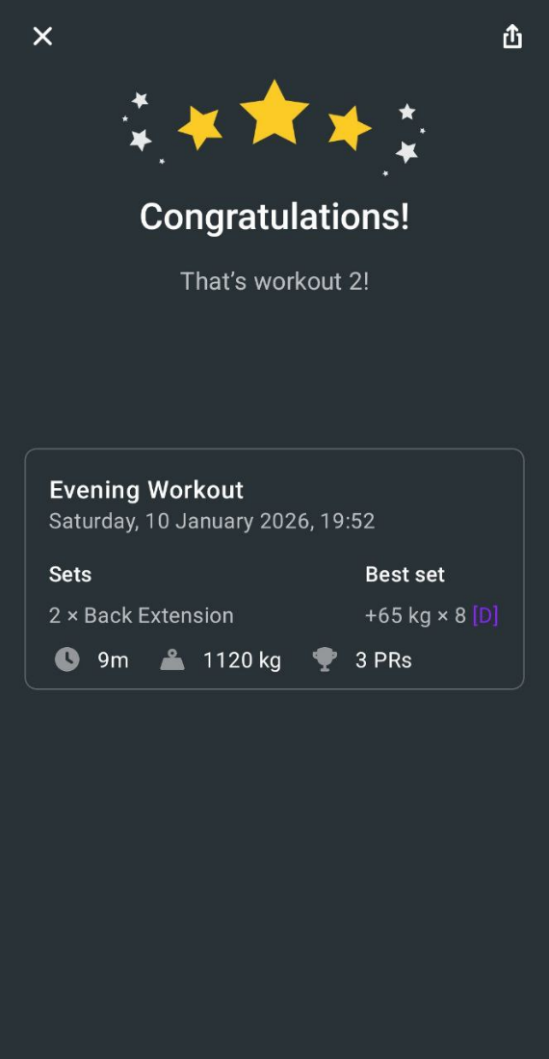
Figure 29: Strong finish workout screen Figure 30: Strong after workout logging screen
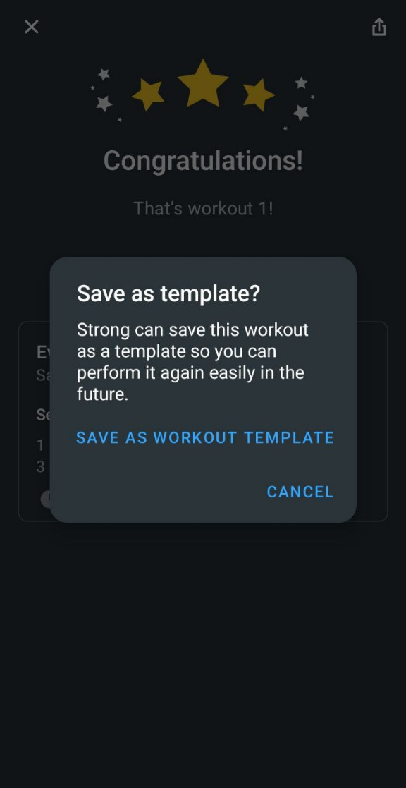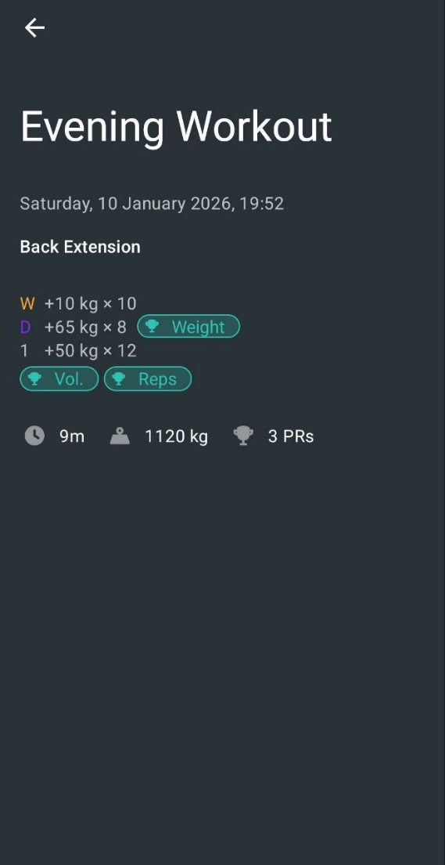
Figure 31: Strong save workout? Figure 32: Strong workout results

Summary:
To access the application, users are required to register and create an account. The user interface is relatively simple, making it easy to locate the workout logging feature. Users can select an existing workout programme to follow or create a custom workout. Exercises can be added easily, with options to select weights, repetitions, and the number of sets. Sets can also be categorised, such as warm-up sets, drop sets, or sets to failure. The application does not allow users to manually define a personal record (PR); instead, PRs are automatically assigned when the heaviest weight is recorded, which may be inconvenient for some users. After each set, a default two-minute rest timer is applied, although this can be adjusted or disabled. Once the rest period ends, the device vibrates and plays a notification sound. Additional features include the ability to add notes, delete unfinished exercises, or mark them as completed. After completing a workout, users can view detailed exercise statistics and save the session to their workout history. Overall, the application provides a convenient and feature-rich workout logging experience and presents useful ideas relevant to the proposed project.

Hevy
Hevy[12] is a strength training app that combines workout logging with analytics and performance tracking. Users manually record exercises, and the app analyzes performance trends throughout the workout, providing statistics such as volume progression and personal records.

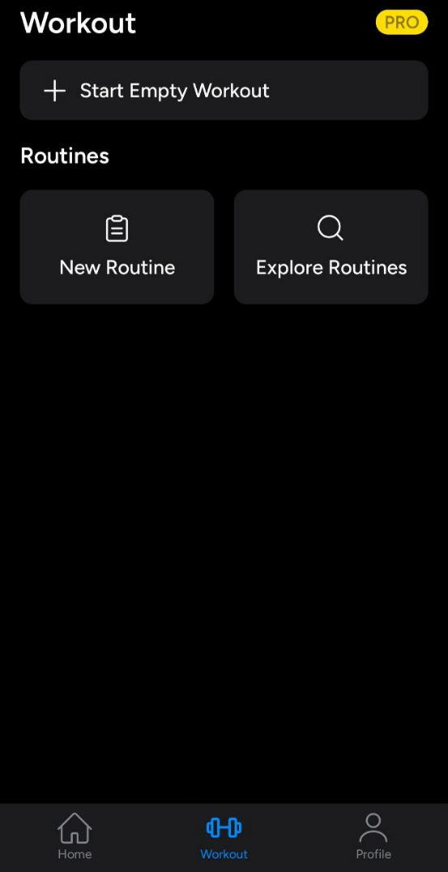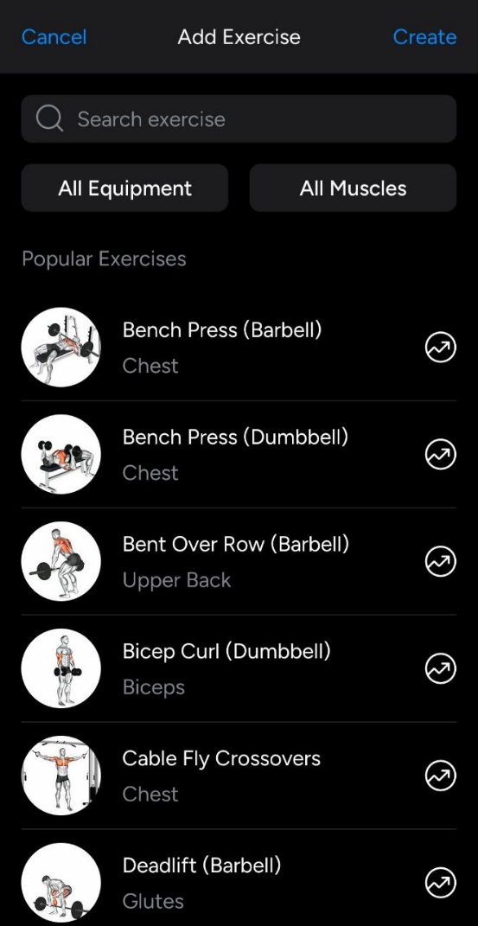
Figure 33: Hevy workouts main screen Figure 34: Hevy exercise choice

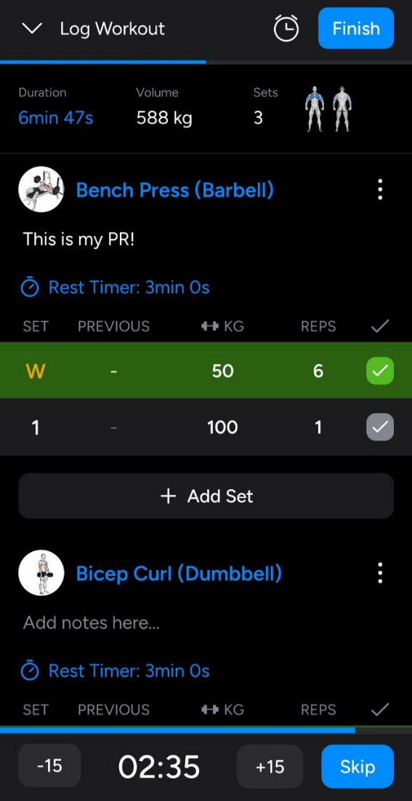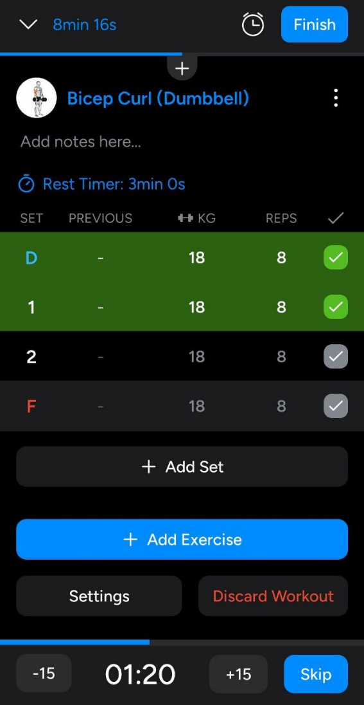
Figure 35: Hevy workout logging screen #1 Figure 36: Hevy workout logging screen #2

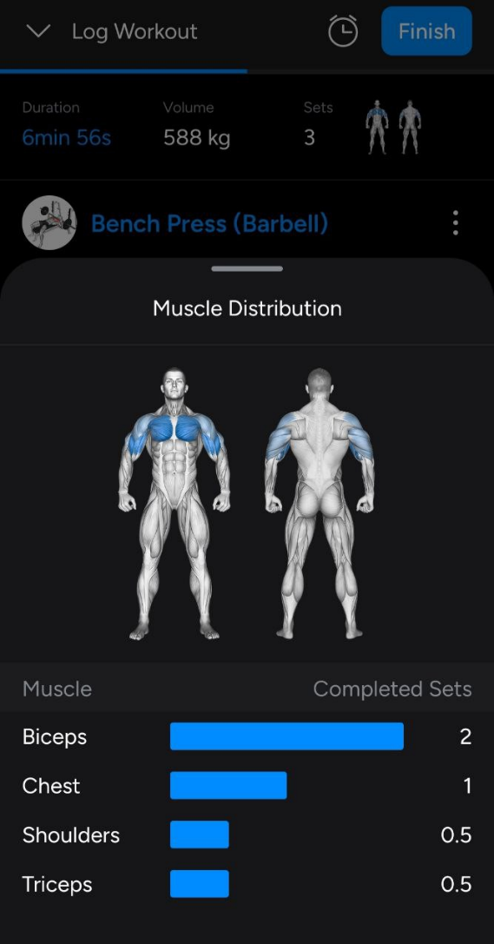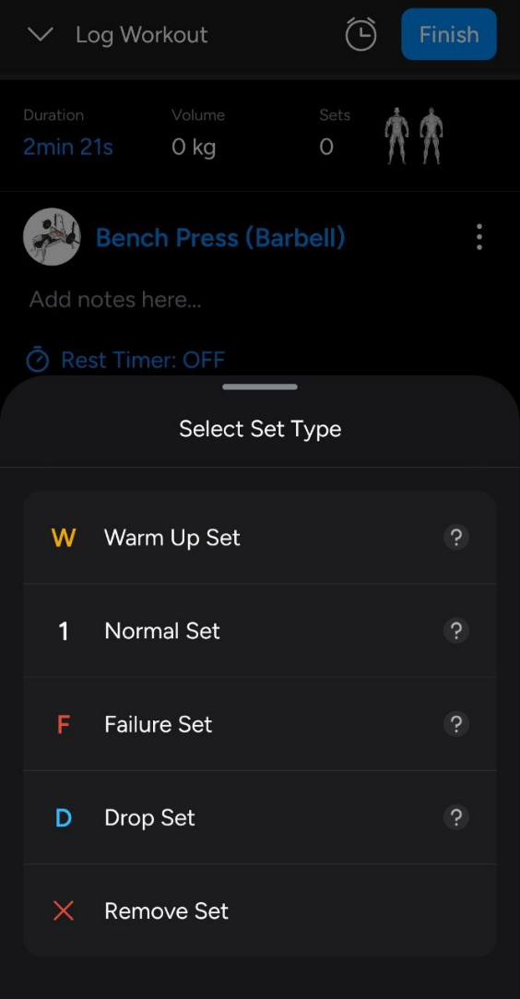
Figure 37: Hevy muscle groups used Figure 38: Hevy set types

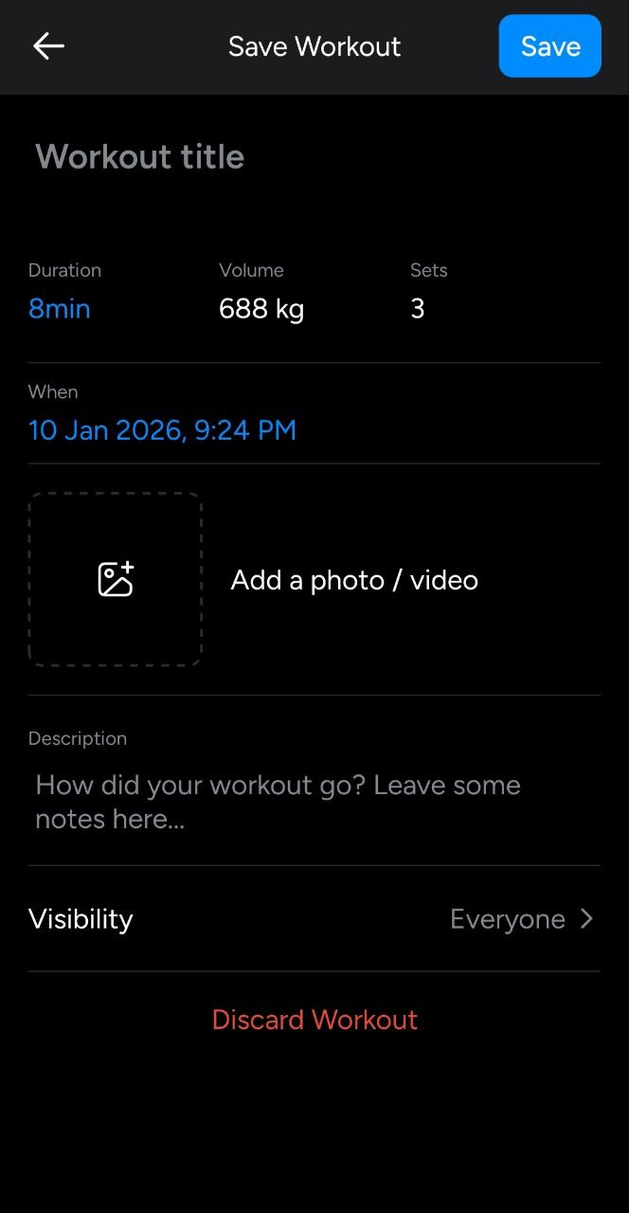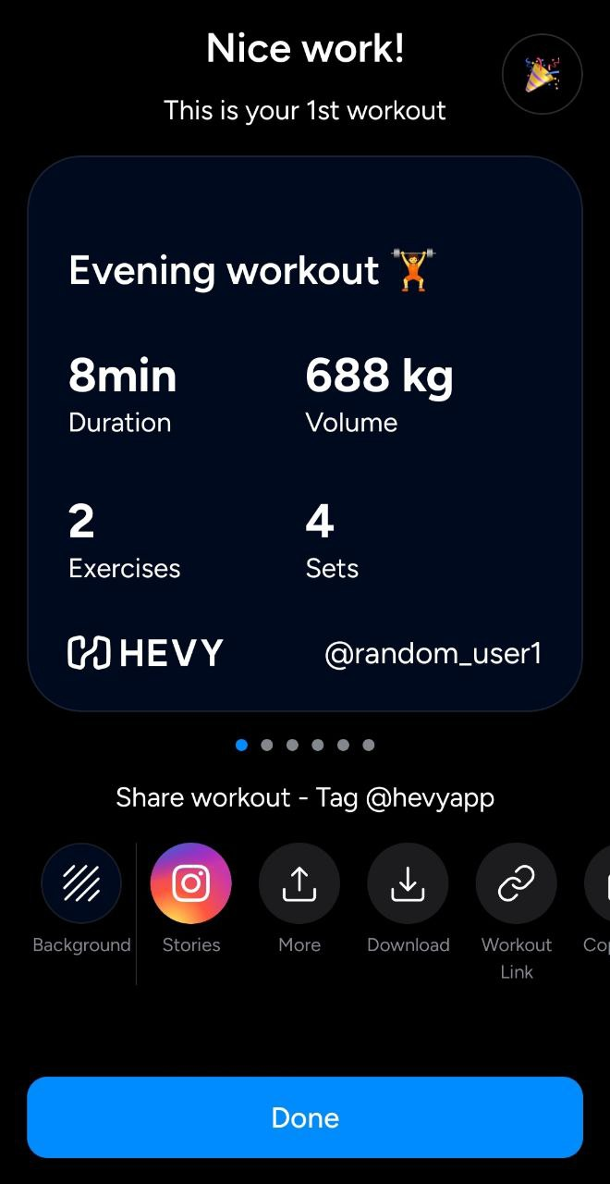
Figure 39: Hevy save workout? Figure 40: Hevy workout results screen

Summary:
Literally the same functionality and the same idea as the previous application.

Comparison Strong vs Hevy:
The apps were virtually identical, but there were some minor differences. Hevy had a simpler and more user-friendly interface than Strong. In Hevy, you had to set a manual rest timer for each exercise, whereas in Strong it was automatic. In Hevy, every time you pressed the end button for an exercise, the muscles you were using would be highlighted in the human model.

Comparison Table
Table 1: Literature review application comparison table
Feature | Application | Platform | Key Strengths | Key Limitations
Feature 1:  Pose  estimation techniques | MediaPipe | Mobile (Android,  iOS), Web,  Desktop | Real-time pose estimation, lightweight, optimised for mobile devices, easy integration with mobile  apps | Limited customisation of  models, less accurate than heavier frameworks in  complex scenes
Feature 1:  Pose  estimation techniques | OpenPose | Desktop, Server | High accuracy multi-person pose estimation, detailed keypoint detection | Computationally expensive, not suitable for real-time mobile use without optimisation
Feature 2:  AI-guided  Fitness  platforms | Tempo | Mobile + Dedicated hardware | Automatic exercise recognition, real-time feedback, strong AI  integration | Requires a controlled environment, often  hardware-dependent, subscription-based
Feature 2:  AI-guided  Fitness  platforms | Freeletics | Mobile | Personalised AI-driven workout plans, adaptive training programs | No camera-based exercise recognition, relies on  manual exercise selection
Feature 3:  Exercise info  platforms | StrengthLog | Mobile | Clear exercise descriptions, muscle group information,  and a clean logging  interface | Half of the content is paid,  the user interface can be confusing, not ideal for  model training
Feature 3:  Exercise info  platforms | Muscle  &  Strength | Web | Detailed exercise  instructions, educational content, and a large  exercise database | No disadvantages, perfect  for model training
Feature 4:  Weight, reps,  sets logging | Strong | Mobile | Fast and simple workout logging, minimalistic  design, good usability  during workouts | Automatic setting of  personal record  (Not always convenient)
Feature 4:  Weight, reps,  sets logging | Hevy | Mobile | Advanced progress  tracking, analytics,  personal records, strong visualisations | Automatic setting of  personal record  (Not always convenient)

Competitor Analysis/ Related Work
This section analyses existing technologies and applications related to exercise recognition, posture estimation, and AI-powered workout tracking. The goal is to identify the strengths, limitations, and gaps of existing applications and to justify the design decisions made in this project.
As no single application was identified that satisfies all the defined goals and requirements, several applications with different objectives are compared. Their advantages, relevant features, and limitations are examined in order to identify elements to incorporate into the proposed application and aspects to avoid.
The applications reviewed are categorised into the following groups:
- Pose estimation techniques (MediaPipe, OpenPose)
- AI-guided fitness platforms (Tempo, Freeletics)
- Exercise info platforms (Strong, Hevy)
- Weight, reps, sets logging platforms (StrengthLog, Muscle & Strength)
Pose estimation techniques
As the proposed application relies on camera-based motion capture in real time, MediaPipe is considered the most suitable framework. It allows for the use of mobile phone cameras and provides fast data processing with relatively low computational requirements. However, MediaPipe provides a limited number of body keypoints, which may limit its performance in some cases. For example, when a group of friends is working together. However, this shouldn't be a problem as long as only one of them is in the camera's field of view.
An alternative framework considered is OpenPose. It offers a more detailed skeletal model with a larger number of keypoints, which will ensure higher accuracy of detailed motion analysis. However, this comes with the risk of requiring significant computational resources. Also, unlike MediaPipe, OpenPose is primarily designed for desktop computers or servers and doesn't use real-time mode, which is completely unsuitable for the PoseFit AI project. So, the high accuracy of detailed motion analysis isn't worth choosing this framework.

AI-guided fitness platforms
Tempo and Freeletics use artificial intelligence for different purposes. PoseFit AI's use of AI will also differ. Tempo uses computer vision and machine learning to provide real-time exercise feedback through camera analysis. Freeletics focuses on personalising workouts using AI.
The proposed application adopts a different approach. It is designed to use a trained machine learning model to recognise and analyse human movements and postures in real time, before providing the exercise name and relevant instructional information. It's somewhat similar to Tempo, as it also uses machine learning and a real-time camera.

Exercise info platforms
StrengthLog and Muscle & Strength provide excellent resources for users interested in what exercises are, how to do them correctly, and which muscle groups they target. The problem is that to find the right app, users need to know at least its name, which isn't always clearly given the vast number of different exercises.
The proposed application eliminates this problem, as simply using the camera while performing the exercise will show all the information users need.

Weight, reps, sets logging platforms
Strong and Hevy are similar apps, and both feature a custom workout feature that lets users add various exercises, reps, weights, and sets. They can not only create and save their own workout but also use pre-made ones. These applications also offer a bunch of other features, such as adding notes, setting a timer for rest periods, and so on.
The proposed application does not aim to include a custom workout feature, and it'll be much simpler. Instead, it focuses on allowing users to be able to add only their personal bests, so they can see how much weight they can lift.

Identified gaps in existing platforms
The analysis of current competitors reveals several consistent limitations:
- Lack of automatic exercise recognition in standard gym environments
- Dependence on manual exercise selection
- Heavy reliance on subscriptions or proprietary hardware
- Limited consideration of privacy and on-device processing
- Fragmentation of features across multiple applications
No reviewed solution combines real-time pose estimation, exercise identification, instructional content, and workout logging into a single, lightweight mobile application.

Tools and Methods
In this section, the way of how the project is performed and the main factors which impact on the technical and methodological choices are described. The development of the project is based on the design-and-build principle, while the research and experimentation, as well as the continuous improvement support the project development. The choices made concerning tools, frameworks, and methods are based on the results of the literature review, competitor analysis, practical limitations in terms of performance, usability, and privacy.
The artefact is created by taking the form of a mobile application that captures human motion with the use of a smartphone camera and applies pose estimation algorithms to identify exercises. The data of human poses is collected in real time and processed by means of machine learning in order to detect exercise patterns. The identified exercise is then displayed to the user with the associated information on how to perform it and not required but optional manual entries into the workout data including sets, repetitions and weights.
The project data collection comprises of recorded exercise videos that were used in the experimentation and testing of pose estimation and classification methods. None of the personal information is captured unless users agree to it and all processing is made to happen on the device where it can. This strategy complies with the legal and ethical demands concerning data protection and privacy.
The process of development adheres to the evidence-based design methodology, with system architecture, user interface design and functionalities being smoothly improved, depending on the technical feasibility, the usability guidelines, and the comments provided during the supervision sessions. Technical decisions are constantly judged in accordance with the legally, ethically, and professionally identified, and the system is safe, open, and responsible.

Rationale for the technical tools selected
A number of technologies and tools were chosen in order to facilitate the adoption of the proposed system with regard to appropriateness, performance, and matchability with the requirements of the project.
Flutter has been selected as the main development framework of the mobile application since it can be used to develop both Android and iOS modules based on one codebase. This makes the development less complex and also provides a consistent user interface and performance across platforms. Other native development models were also thought of but they were not adopted because they required more time to develop and maintain.
MediaPipe was chosen to be used in human pose estimation because it can be used to provide real-time processing on mobile with comparatively small computation needs. MediaPipe is smaller in size than other options like OpenPose and can be deployed to an on-device processing system and a mobile platform. Even though OpenPose has a more detailed skeletal model, it has more hardware requirements and is not supported by real-time mobile applications, thus not fitting this project.
The training and evaluation of machine learning models to classify exercises are supported by the TensorFlow. It is flexible and scalable with good community support, so it is suitable to be used in experimentation and extended in the future. Other simpler rule-based methods were also taken into consideration and discarded because of the lack of adaptability and accuracy in the ability to identify more complex patterns of movements.
The non-sensitive user data and workout logs are stored in a SQL-based local database that ensures the management of data in a structured and efficient way. Platform-specific secure storage procedures are used to process sensitive authentication data and ensure confidentiality and adherence to the principles of data protection.
GitHub provides support to project management and documentation, version control, issue tracking, and Kanban boards. This allows the process of clear organisation of tasks, monitoring of progress and indication of iterative development in the project life cycle.

Rationale for the research methods used
The project will be based on an applied research approach that involves a qualitative and technical research design.
To examine the current literature regarding pose estimation, exercise recognition, and AI-based fitness apps, a literature review is carried out. This will give a basis of evidence regarding the choice of technologies and the gaps in the existing solutions.
An evaluation of strengths and limitations is carried out through a comparative analysis of available applications and frameworks, which aids in refining the project requirements and making decisions in the design.
The technical implementation is developed in the form of an experiment. This involves generation of datasets, pose estimation accuracy testing, and cyclic process of refining the exercise recognition model with regards to perceived performance.
The methods of evaluation will involve:
Accuracy of exercise recognition in functional mode.
Mobile interface usability test.
Ethical, legal and professional reflection.

Project management and Product lifecycle
The project management of this project is facilitated by the application of the GitHub Projects and Kanban boards, which is utilised to plan the tasks, monitor the progress, and control development activities on all project phases. The tasks are categorized into rational stages, which include research, development, testing, and documentation, and the development can be reviewed and reported on a regular basis.
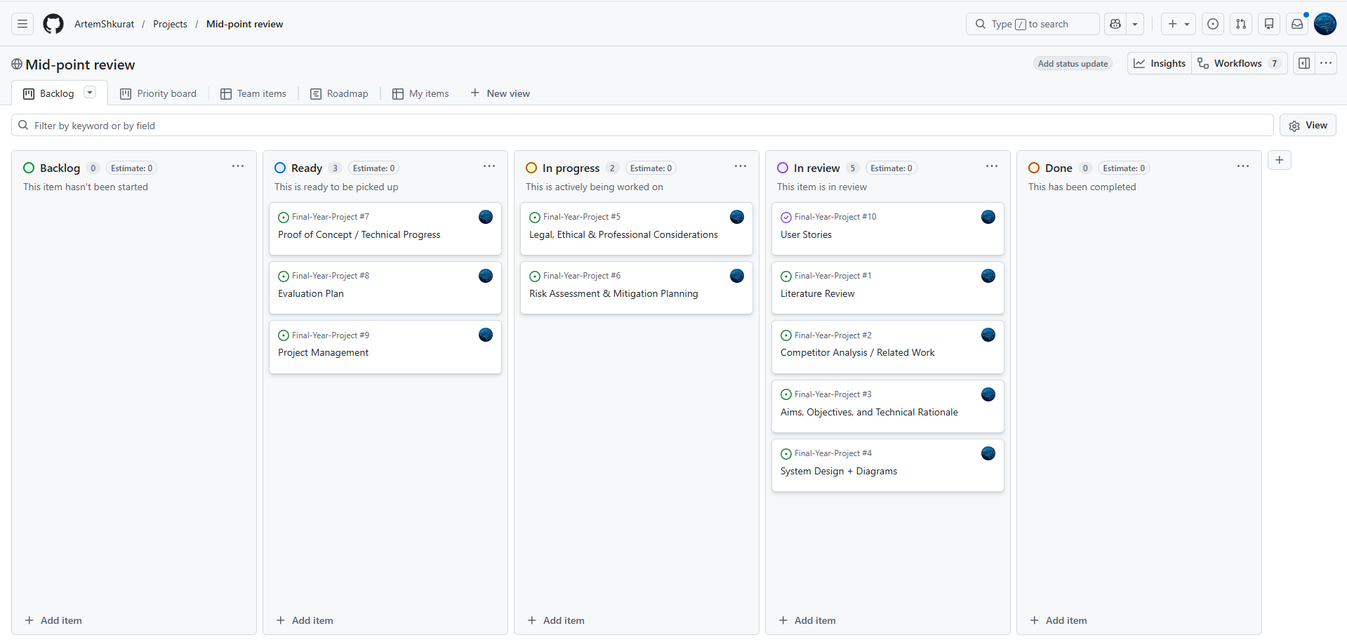
Figure 41: Kanban board
Beside a Kanban board, there is the Gantt chart that plans and visualises the timeframe of the project in general. The Gantt chart gives a logical view of the important milestones, the time allocated to various tasks and dependencies such as research and literature review, application development, model training, integration, evaluation, and final submission. The method will enable efficient time management, chances of the probable risks that appear during the schedule, as well as alignment of the project with the academic due dates.
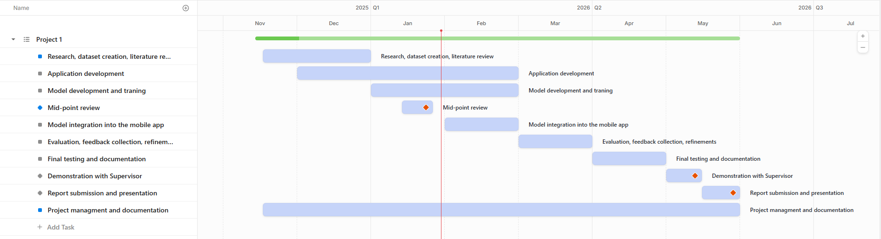
Figure 42: Gantt chart
The project is based on an iterative and agile-inspired development lifecycle, in which the feedback on supervision sessions and evaluation activities is applied to improve the design decisions and implementation during the development process.

Legal, ethical and Professional issues
This section discusses the importance of potential legal, ethical, and professional considerations related to the proposed mobile application. Addressing these considerations is essential to ensure that the project does not violate any laws, complies with relevant regulations and legal obligations, and remains responsible and fair to users. This section also outlines how these considerations are addressed and how responsibility is taken in various situations throughout the project.

Legal Considerations
(1) User Consent and Camera Access
Issue:
Using the camera without the user's consent may violate data protection laws.
Solution:
The app's camera won't be usable until the user consents. After consent, the app will clearly inform users when the camera is active, and its access can be easily disabled through the app's settings.
(2) Data Privacy and Protection
Issue:
When using the camera to recognise an exercise, the video is processed by a model to identify key points on the user's body, which, according to the UK GDPR, may be classified as personal data. The user may not be aware of how the app uses this data and may be concerned that it could be shared without their knowledge.
Solution:
The app will contain a link to the Privacy Policy, which states:
1. The app does not save or upload any user videos.
2. Only basic workout information (e.g., exercise name, number of sets, reps, and weight) is saved and stored locally on the device.
3. What data is used, why it is needed, and how it is protected.
(3) Data Storage
Issue:
Storing personal data longer than necessary or without user control may breach GDPR data minimisation and storage limitation principles.
Solution:
All user data is stored locally on the device, so you can manually edit or delete workout records if you wish.
(4) Account Security
Issue:
Users may have concerns about insecure processing of authentication data and data leakage.
Solution:
User authentication credentials will never be stored in cleartext. Secure platform-specific storage mechanisms will be used for their storage.
(5) Liability
Issue:
Users may interpret exercise recognition and exercise technique recommendations as professional or medical advice, which could potentially lead to injury or misuse.
Solution:
The app will include unavoidable disclaimers next to the feature, which will state that the app does not provide professional or medical advice and that exercise information is provided for educational purposes only.

Ethical Considerations
(1) User Privacy
Issue:
The user may feel uncomfortable knowing that the camera is analyzing his/her movements.
Solution:
If the user feels uncomfortable using the camera, the app offers a manual option to find an exercise. However, if the user still wants to use the camera, they will first need to grant permission. Even then, the camera is used in real time and does not save video without the user's consent.
(2) Bias in AI Recognition
Issue:
Artificial intelligence models may be biased against certain groups of people, which could lead to unfair or inaccurate assessments of the effectiveness of exercise. Such groups may include people with certain body types, genders, clothing styles, and races.
Solution:
To reduce model bias, it will use training data that covers a wide and diverse range of users. Exercise recognition will also primarily focus on movement patterns rather than appearance.
(3) Risk of Misclassification
Issue:
If the app misidentifies the exercise, users may be misinformed or confused about what they are doing.
Solution:
The app won't show exercise recognition results if the model's confidence isn't high enough and will request a re-shoot. The user can also find or log the exercise manually if needed.
(4) User Safety
Issue:
Users may rely on the app's recommendations but perform the exercises incorrectly, which could potentially increase the risk of injury.
Solution:
The disclaimer will clearly state the limitations of the system and state that the app is only intended to help users understand the exercises and is not a replacement for a personal trainer.
(5) Transparency
Issue:
Users may not understand how and why the AI ​​system recognises a particular exercise, which can reduce trust in the app.
Solution:
The manual will explain how the application functions and its main features.

Professional Considerations
(1) Professional Use of Third-Party Technologies
Issue:
Incorrect integration and failure to adhere to the expiration dates of third-party libraries can lead to unexpected risks and problems with code.
Solution:
Always check dependencies for reliability, suitability, and expiration dates. Also, avoid using libraries from suspicious or unfamiliar websites.
(2) Help, Support, and User Guidance
Issue:
If users do not understand how to use the application, this may cause confusion, misuse of features, or incorrect assumptions about exercise performance.
Solution:
The application will provide clear in-app guidance, such as brief explanations and tooltips. This will help users understand key features and reduce the risk of user error.
(3) Timely support
Issue:
If users have had a poor experience using the app, they may be tempted to use the Help and Support features. A delayed response to user complaints can undermine their trust and loyalty.
Solution:
Always be ready to help users with problems. Treat all their concerns with respect and understanding.

Risk register
This section focuses on reviewing, assessing, and mitigating all risks that may be associated with the PoseFit AI application.
Risks:
R1: The pose-estimation model may incorrectly classify exercises (especially when movements are similar or partially occluded).
R2: Real-time position estimation may produce poor results on older or low-power mobile devices.
R3: Insufficient or undiversified training data may reduce the accuracy of the model when dealing with different body types, camera angles, or conditions.
R4: Improper handling of access to cameras or video data.
R5: Underestimating the time required to train, test, and refine a model.
R6: Failure to follow or deviation from the application development plan.
R7: Complex workflows or an unclear user interface can make the app difficult to use.
R8: Users may treat app feedback as professional fitness advice.
R9: Changes, deprecation, or licensing issues with MediaPipe, TensorFlow, or other libraries.
R10: Insufficient user testing or evaluation results.
R11: The posture estimation model may not be able to recognize the exercise in some cases.
R12: Workout logs or user data may become corrupted due to crashes or improper handling.
R13: Errors in pose detection or classification may be hard to trace.

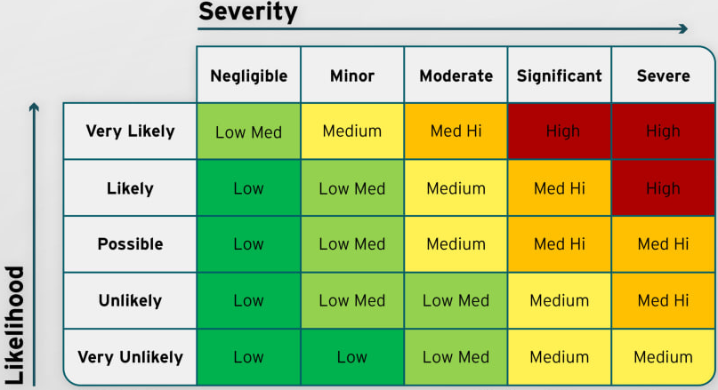
Figure 43: Risk assessment
Table 2: Risk register table
Reference | Probability | Impact | Risk Score | Mitigation Actions
R1 | Possible | Moderate | Medium | Train the model on a variety of different data  until its accuracy increases too virtually  error-free.
R2 | Likely | Moderate | Medium | Add a feature to the camera settings for  phones with poor performance that will limit camera processing to a single detected user.
R3 | Possible | Significant | Med Hi | Collect a variety of training data covering different body types, angles, lighting  conditions, and environments.
R4 | Unlikely | Severe | Med Hi | Ensure explicit user consent, avoid storing video files, and comply with GDPR and UK data protection regulations.
R5 | Likely | Significant | Med Hi | Find and prepare all the necessary data for training the model in advance. Prepare a  plan to follow.
R6 | Possible | Moderate | Medium | Break the plan into smaller chunks to make it easier to follow. Maintain and regularly  update the project plan. Use Kanban boards  and management feedback to track progress and adjust tasks as needed.
R7 | Unlikely | Significant | Medium | Apply usability guidelines. Create interface prototypes and then follow them. Collect user feedback and simplify workflows where necessary.
R8 | Unlikely | Significant | Medium | Clearly state disclaimers that the app is not a substitute for professional advice.
R9 | Unlikely | Severe | Med Hi | Monitor updates and licenses for third-party libraries. Prepare alternative frameworks.
R10 | Possible | Minor | Low Med | Conduct usability testing with a large number of users. Analyze all the feedback received and draw conclusions.
R11 | Possible | Moderate | Medium | If exercise recognition fails, make the system ask the user to film the exercise from a different angle.
R12 | Unlikely | Significant | Medium | Use database transactions, input validation,  and exception handling. Regularly test  save/load operations and handle app  lifecycle events correctly.
R13 | Possible | Significant | Med Hi | Add debugging mechanisms during the development phase. Use clear model  evaluation metrics and step-by-step testing  of pose detection and classification stages.

Requirements/Specifications
Personas
Table 3: Persona 1
Picture | Description
Goals  Frustrations  Wishes | Scenario

Table 4: Persona 2
Picture | Description
Goals  Frustrations  Wishes | Scenario

Table 5: Persona 3
Picture | Description
Goals  Frustrations  Wishes | Scenario

User stories
- As a user, I want to recognize exercises using the phone's camera, so that I can save time searching for it on the internet.
- As a user, I want to see the name of the exercise when searching for it, so that I can memorize it and use it later.
- As a user, I want to know which muscles are being used in different exercises, so that I can better understand what to train.
- As a user, I want to see the instructions on how to perform the exercise correctly, so that I don’t injure myself doing it wrong.
- As a user, I want to see a visual representation of how to perform the exercise correctly, so that I can repeat after it.
- As a user, I want to keep a record of the number of repetitions, sets, and weight I use during the training, so that I don't have to worry about memorizing them.
- As a user, I want to keep track of my PR (Personal Record), so that I can be sure I’m progressing.
- As a user, I want to delete or edit my own exercise entries, so that if I don’t need them or want to change them.
- As a user, I want to see a list of all exercise records, so that I can see what weight I used last time.
- As a user, I want to see the date when an exercise entry was saved so that I can easily identify the last time I performed that exercise.
- As a user, I want to filter exercises by name and date, so that I can easily find the one I need.
- As a user, I want to have an option to choose between kilograms and pounds, so that I can choose the most suitable one.
- As a user, I want to create or log in to an account, so that I can personalize the app.
- As a user, I want an app to ask for permission to use the camera or save user data, so that I feel safe in relation to personal information.
- As a user, I want to see an explanation of how the user's personal information is used, so that I can make an informed decision about using the app.

User journeys

Use case diagrams
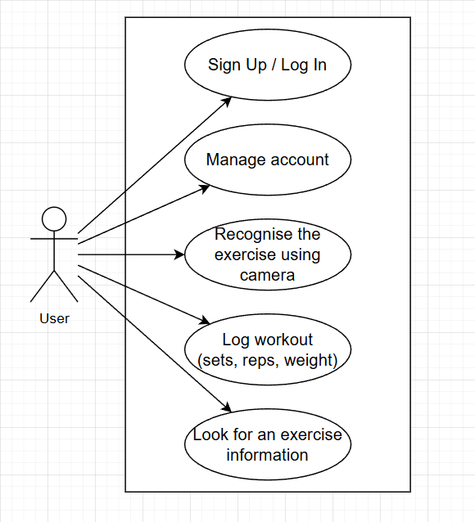

Wireframes
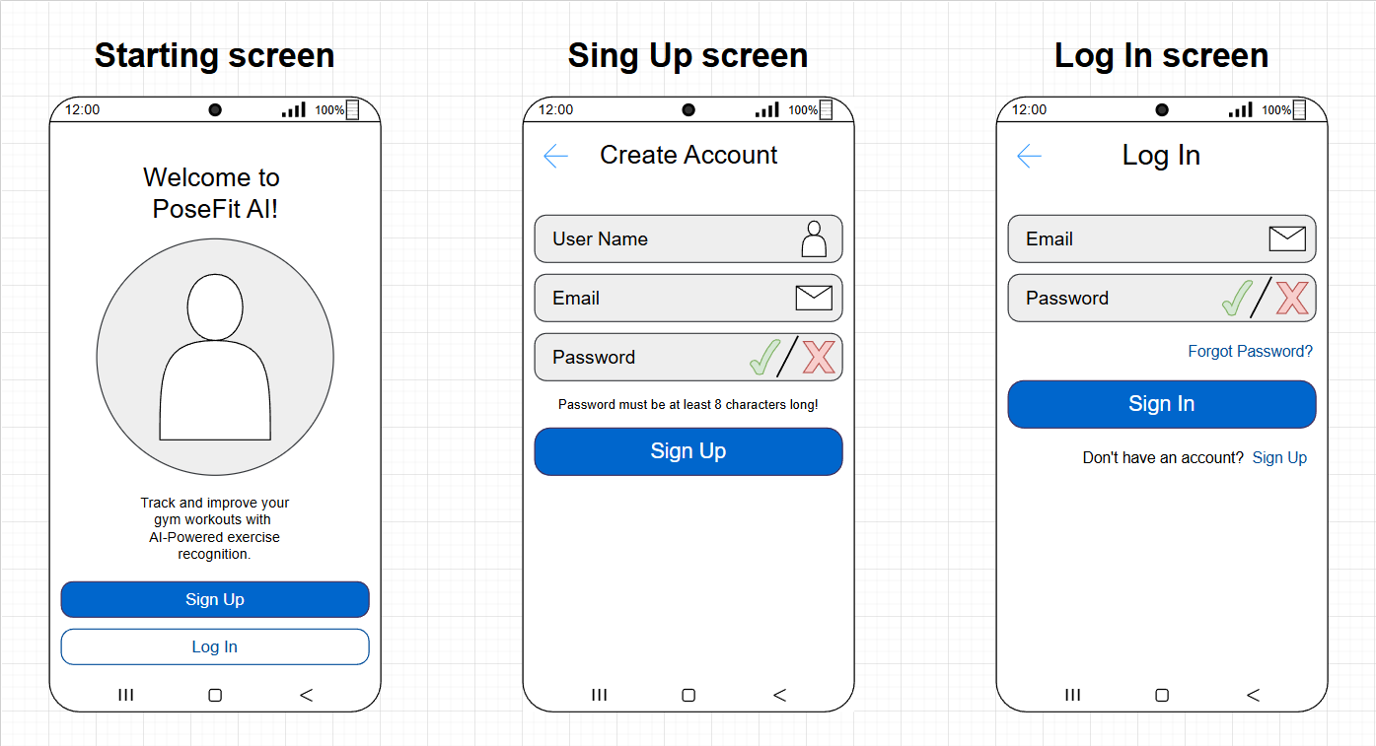
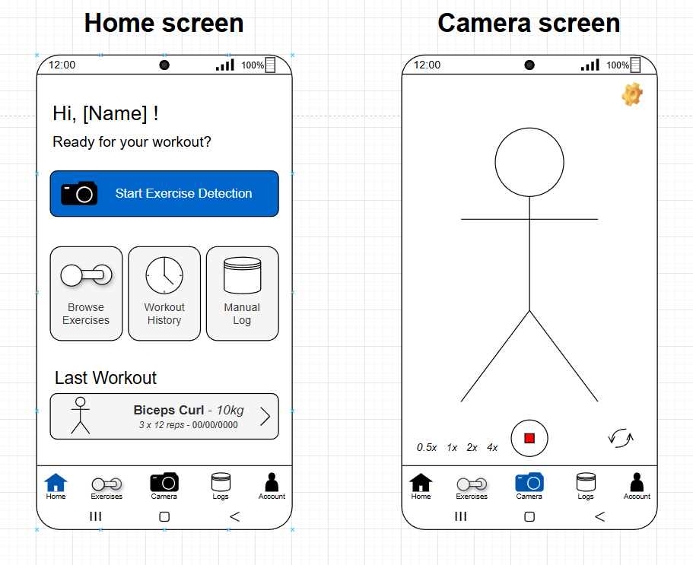
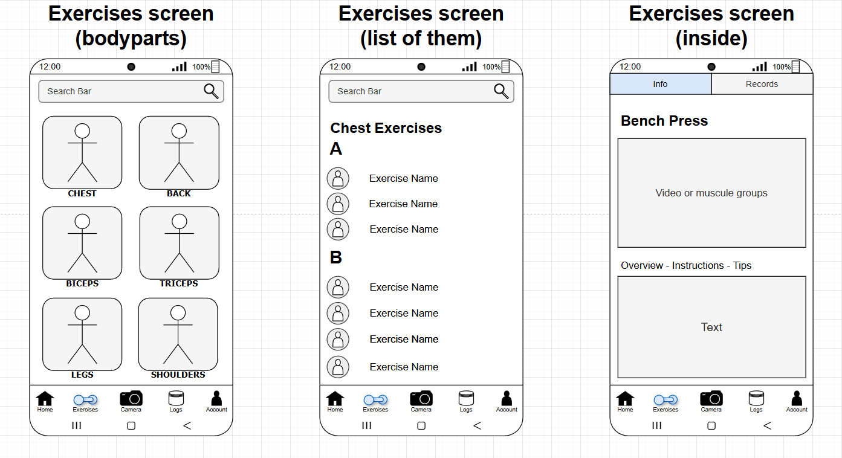
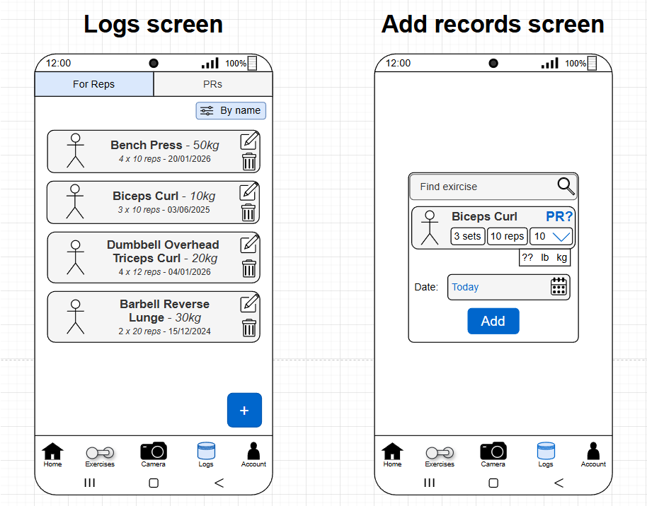
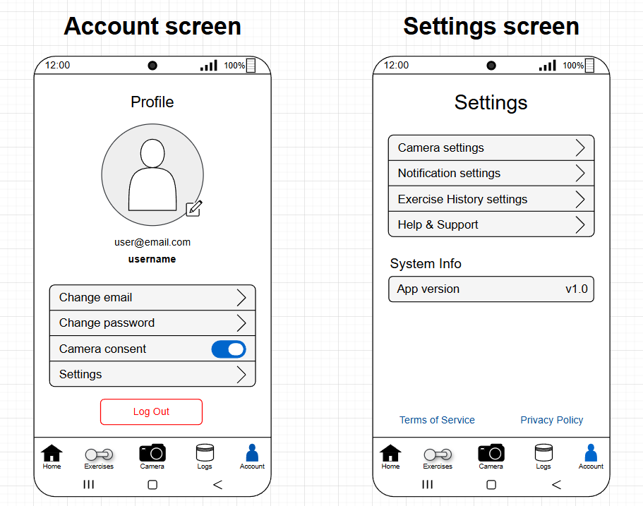

User flow diagrams

Solution design
This section should document the technical plan that you have used to create your artefact, for example
- UML class and sequence diagrams
- ERD diagrams
- network diagrams.

Solution implementation
Give a detailed account of how you have created your artefact. You are advised to divide this section up so that it matches your project plan, for example by describing the work you did in each sprint.
Consider choosing a particular technical challenge that you faced in each sprint and providing some detail (backed by evidence) of how you solved the challenge. Only include code snippets for particularly challenging parts of your implementation.
This section is all about your experience and therefore should be easy to write! Prepare for this by keeping a detailed log of all of your activities and using your github commits descriptively.

Solution testing/ evaluation

This is an important section where you weigh up the strengths and weaknesses of your artefact.
Guidance: If your project has a user-facing element, we expect to see some kind of evaluation of this with representative intended users, for example a ‘think aloud’ usability test.
You can also apply standard metrics for the domain you are working in and see how you have done against them. Your project does not have to be perfect -- indeed the outcomes might have been bad. The point is you must evaluate the outcome and discuss its strengths and weaknesses.

Discussion

This is a key section in which you summarise your findings, compare them to the findings of similar studies and draw conclusions about what your research has revealed.
Tie your discussion to specific evidence or activities that you have gathered and included in earlier sections of your report.

Conclusion

Summary
Briefly summarise your activities and findings.

Recommendations for further work
In this section, list some activities that you would undertake to improve your project if you had more time. Make sure these are realistic and based in evidence from your evaluation section.

Reflection
Finally, critically reflect on the entire project process and how well you have worked on the project. What particular things have you learned during the project? Why were you able and unable to meet project goals? What would have you done differently in hindsight? Write this section in the first person.

References
[1]
Hevy, “Hevy.” Accessed: Jan. 10, 2026. [Online]. Available: https://www.hevyapp.com/
[2]
M. & Strength, “Muscle & Strength Exercise Directory.” Accessed: Jan. 10, 2026. [Online]. Available: https://www.muscleandstrength.com/exercises
[3]
G. AI, “MediaPipe (Pose Landmarker).” Accessed: Jan. 08, 2026. [Online]. Available: https://ai.google.dev/edge/mediapipe/solutions/vision/pose_landmarker
[4]
Strong, “Strong.” Accessed: Jan. 10, 2026. [Online]. Available: https://www.strong.app/
[5]
G. AI, “MediaPipe (GitHub Repository).” Accessed: Jan. 08, 2026. [Online]. Available: https://github.com/google-ai-edge/mediapipe?tab=readme-ov-file
[6]
M. & Strength, “Total Package Workout.” Accessed: Nov. 16, 2025. [Online]. Available: https://www.muscleandstrength.com/sites/default/files/workouts/totalpackage.pdf
[7]
R. Blog, “OpenPose (Official Website).” Accessed: Jan. 08, 2026. [Online]. Available: https://blog.roboflow.com/what-is-openpose/
[8]
F. AG, “Freeletics.” Accessed: Jan. 08, 2026. [Online]. Available: https://www.freeletics.com/en/
[9]
C. P. C. Lab, “OpenPose (Documentation).” Accessed: Nov. 15, 2025. [Online]. Available: https://cmu-perceptual-computing-lab.github.io/openpose/web/html/doc/index.html
[10]
StrengthLog, “Exercise Directory.” Accessed: Nov. 16, 2025. [Online]. Available: https://www.strengthlog.com/exercise-directory/
[11]
G. AI, “MediaPipe (Solutions Guide).” Accessed: Nov. 15, 2025. [Online]. Available: https://ai.google.dev/edge/mediapipe/solutions/guide
[12]
T. Fitness, “Tempo.” Accessed: Jan. 08, 2026. [Online]. Available: https://tempo.fit/

Appendices
Appendices appear after references. Your appendices depend on the nature of your project. Do not assume people will read your appendices. Even if you direct them to do so in your main text, appendices are considered additional information and should not be relied upon to understand your main body of work. Refer readers to an appendix using a phrase such as see Appendix A for further details.
The following documents must be included as references:
- Your Project Proposal poster
- Evidence of your use of a project management tool eg. screenshots
- A description of how to access any technical output. It is strongly recommended you use GitHub or something similar to do this.
- Your ethics form
- Your risk register
- Any important communications between you and external stakeholders -- please ensure private data is removed and communications anonymised.

